**Overfitting, Underfitting and Model Selection**

**TOTAL POINTS 2**

1.

Question 1

what model should you select

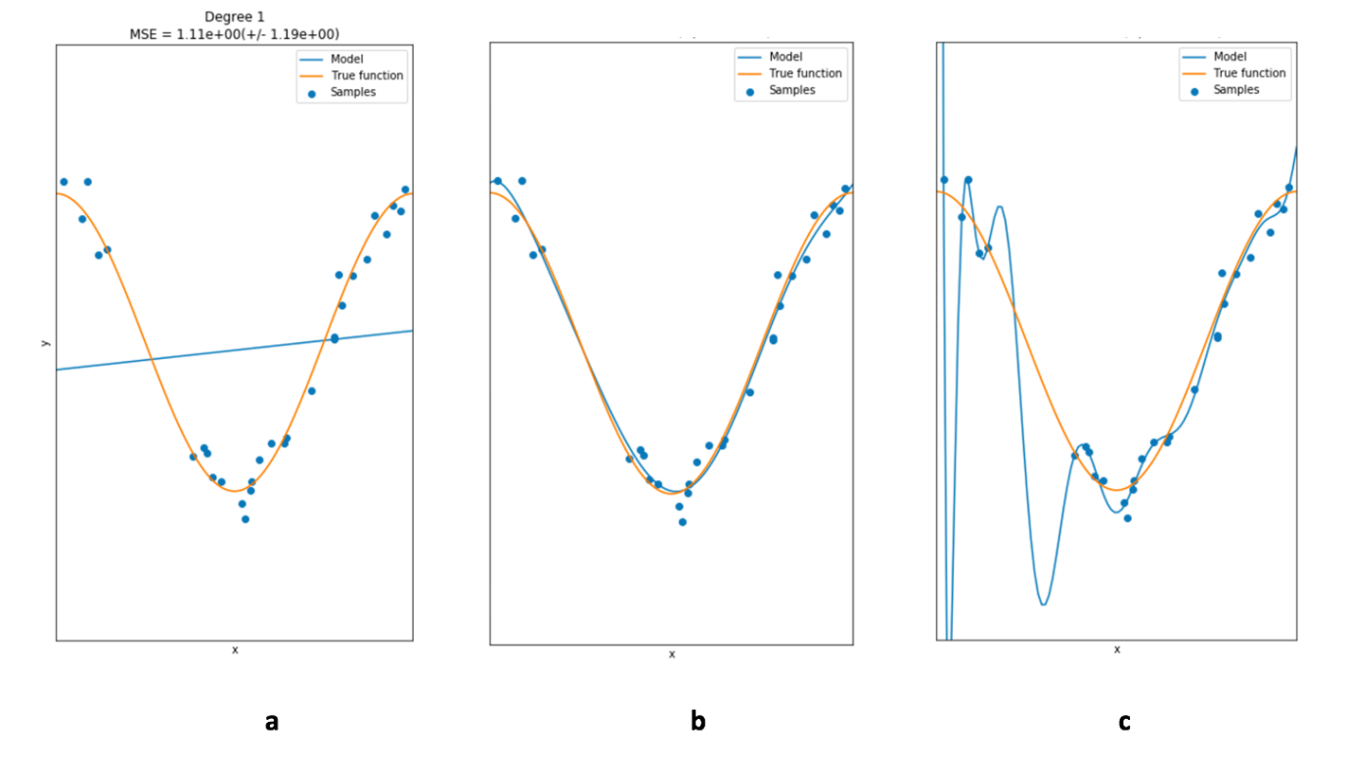

1 point



a



c



b

2.

Question 2

The following is an example of:

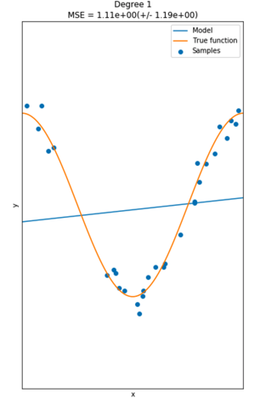

1 point



overfitting



perfect fit



underfitting